**Observation Station Eindhoven**

**Location: Eindhoven central Train station**

**Date of observation: 28-09-2023 & 29-09-2023**

**Observation time: 8:00AM-9:00AM & 3:00PM-4:00PM**

**Summary:**

During my observation at the Eindhoven station I mainly focused on the check in and check out process during peak hours, which were observed between 8:00AM - 9:00AM and 3:00PM - 4:00PM. I chose these time slots because I could observe the most people this way, since it is a period where the station experiences the highest influx of passengers, both arriving and departing. I observed the smoothness of the process and the different ways people check-in and check-out.

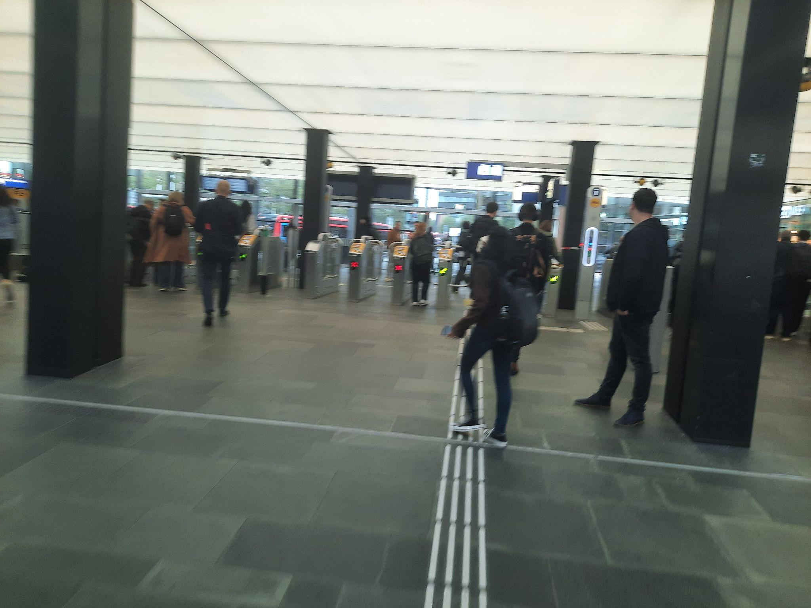

Overall, the check-in and check-out process at the station demonstrated a good level of efficiency, ensuring a smooth flow of passengers. However, upon closer examination, I was able to identify some minor issues that gave rise to some frustration among some users.

**Observation findings:**

1. **Primary Methods for Check-in and Check-out:** I noticed that almost all users used their OV card or phone to get into the station, while a smaller percentage used their bank card.
2. **Crowded Check-in/Check-out lines:** One significant issue during the check-in and check-out process were the crowded lines during peak hours. It is worth noting that the lines to get into the station are not excessively long, but are still perceived as frustrating amongst users, because most people are in a rush to catch their train.
3. **Non-functioning gates:** Another issue is that during the observation I noticed that some gates stopped functioning during the check-in check-out process. This left users frustrated since they had to use another gate to get in or out. This contributed to the delays users experienced.
4. **OV card declines:** Some users experienced issues where their OV cards declined when attempting to check in or out. This unexpected error made users forced to seek assistance or find alternative payment methods.
5. **Gates declining:** Due to fast card scanning some people experienced some gate cancellations. This issue was observed when people tried to pass through gates in rapid succession, leading to the cancellation of subsequent card scans.

**Recommendations for Improvement:**

**Increased Staffing During Peak Hours:** One way to resolve the issue of delays is increasing the staff during peak hours. Make help easily available when someone runs into an issue during check-in or check-out.

**Regular gate maintenance:** Conduct regular maintenance checks to ensure all gates are functioning correctly. This will minimize the occurrence of non-functional gates and reduce user frustration.

**Gate Scanning Optimization:** Implement gate scanning optimizations to prevent the cancellation of subsequent card scans when users pass through gates in quick succession. This can include adjusting gate response times or providing clearer instructions to users regarding the scanning process.

**I asked for some feedback about the observation challenge and my portfolio. Overall I got a positive reaction. My portfolio looked visually appealing and had a good structure. The observation about the check-in and out had some great findings. I got challenged to try and observe the same thing in the station at my home town Roermond (if I find time) to see if there are any differences. I will definitely try to do this, since the challenge was quite fun.**